A



Mini Project Report

On

**Smart Accident**

**Prevention**

**&**

**Alert System**

Submitted in partial fulfillment of the requirements of the degree of

# Bachelor of Engineering

by

|  |  |
| --- | --- |
| **Shah Parth Pravin** | **(119IT3345A)** |
| **Shelar Rutuja Vishnu**  **Patel Jay Ashok**  **Mahadik Omkar Uday** | **(118IT1230B) (****119IT3216A)**  **(****119IT3251A)** |

Under the guidance of

**Prof. Swati Sinha**

Department of Information Technology

Mahatma Gandhi Mission’s College of Engineering & Technology Kamothe, Navi Mumbai – 410 209

## University of Mumbai Academic Year: 2021-22

**CERTIFICATE**

This is to certify that the mini project entitled **“Smart Accident Prevention & Alert System”** is a bonafide work of **Parth Shah (119IT3345A) , Rutuja Shelar (118IT1230B) , Jay Patel (119IT3216A) , Omkar Mahadik (119IT3251A)** submitted to the University of Mumbai in partial fulfillment of the requirement for the award of the degree of **“Undergraduate”** in **“Information Technology”.**

(Faculty In charge)

## Swati Sinha

**DECLARATION**



We declare that this project report entitled **“****Smart Accident Prevention & Alert System”** represents our ideas in our own words and where others ideas or words have been included, we have adequately cited and referenced the original sources. We also declare that we have adhered to all principles of academic honesty and integrity and have not misrepresented or fabricated or falsified any idea/data/fact/source in my submission. We understand that any violation of the above will be cause for disciplinary action by the Institute and can also evoke penal action from the sources which have thus not been properly cited or from whom proper permission has not been taken when needed.

Date:

Place:

**( Signature )**

## ACKNOWLEDGEMENT

The success and final outcome of this project required a lot of guidance and assistance from many people and we are extremely fortunate to have got this all along the completion of our project work. Whatever we have done is only due to such guidance and assistance and we would not forget to thank them.

It is matter of great pleasure for us to submit the project report on **“Smart Accident Prevention & Alert System”**, as a part of our curriculum.

First and foremost, we would like to thank to our director **Dr. Geeta Lathkar**, for giving us an opportunity to do the project work. We would like to thank our H.o.D Prof**. Swati Sinha** and subject incharge, **Swati Sinha** for the valuable guidance and advice. He inspired us greatly to work in this project. His willingness to motivate us contributed tremendously to our project.

And last but not the least a special thanks goes to my team members, who helped me to assemble the information and gave suggestions to complete our project.

|  |  |
| --- | --- |
|  | **CONTENTS** |
| CHAPTER 1 | ABSTRACT |
| CHAPTER 2 | INTRODUCTION |
| CHAPTER 3 | SYSTEM ARCHITECTURE |
| CHAPTER 4  CHAPTER 5 | COMPONENTS  SYSTEM S/W DESIGN & RESULT |
| CHAPTER 6 | PROJECT DESIGN & PYTHON CODE |
| CHAPTER 7 | FUTURE SCOPE |
| CHAPTER 8 | CONCLUSION |

# CHAPTER – 1

# ABSTRACT

Road accidents are one of the major reasons of fatality. The time between the occurrence of accident and the emergency medical facility provided to the accident location is the important factor in the survival rates after the accident. By reducing the time between the accident and medical facility provided to the scene decreases mortality rates so that more lives can be saved. One approach to eliminate that delay is to use Accident Detection Using Raspberry Pi, which gives alert if the accident occurred and immediately notify to the emergency responders. The system is described the main application of which is to recognize the accident using the vibration sensor and give alert message to the respective places. Alert message includes location of the accident, alcohol percentage, disposal of seat belt, speed, number of members in the vehicle. In this system, initially GPS continuously takes input from the satellite and stores the latitude and longitude values. To track the vehicle, we need to send the message to GSM device, so that it gets activated. It also gets activated by detecting the accident on the vibration sensor connected to the raspberry pi controller. Once the GSM is activated it receives the last latitude and longitude position value and send message to the emergency server which is predefined in the program.

# CHAPTER – 2

## INTRODUCTION

The high demands of vehicle have also increased the traffic problems and the road accidents. Due to driver‟s carelessness there occur to demand chief road accidents with the cities, but also outside the city, accident mostly occur due to drunken driving. Not only drunken drive, but also driving rudely without wearing seat belts causes a loss of lives. Due to this the life of public is at high risk. The reason behind this is the lack of best emergency facilities available in our country. An automatic alert system with maximum information of the accident is introduced in this paper. The proposed system which can detect accidents in significantly less time and sends the information to emergency centre with a few seconds which covers the exact location where the accident has been occurred and also the information such as the speed, alcohol percentage, has put the seat belt or not, number of members in the vehicle. This alert massage is been sent to the emergency server which will inform the ambulance, police station near to that location and also to the insurance office, which will help to save the valuable lives.

A switch is also provided near diver seat in order to terminate the sending of message in rare case where there is no casualty, this can save the precious time of ambulance, police. When the accident occurs the alert message is been sent automatically to emergency server. The message is sent through the GSM module and the location is been detected with the help of GPS module. The accident can be detected precisely using vibration sensor. This application provides the excellent solution to the poor emergency facilities which are provided to the road accidents in most possible ways.

# CHAPTER – 3

## SYSTEM ARCHITECTURE

The main essential component of the proposed system is “vibration sensor”. If the accident occur, then it gets detected and the alert message goes to the respective numbers. In which the vibration sensor senses the accident occurrence and initializes the GSM module through which the alert message is sent to emergency server. Alcohol sensor is used to detect weather driver was drunken or not. Limit switch is used to know that seat has been put or not. CO sensor is used give the alert about the fire if vehicle is burned. IR pairs and motor is used to know the speed of the vehicle. GPS is used to track the vehicle i.e. to send the location.

Message is been sent automatically to the GSM device through which it gets activated and then sends the alert message to the emergency numbers of near by ambulance, police station and insurance office. The output from all the sensors is been passed to the raspberry pi controller. When the output is been send to the controller it gives the signal to GSM, which activates and sends alert message. The output of the GPS is linked with the GPS modem, so that whenever the GSM sends an alert SMS to the emergency contacts it sends the location details along with other details.

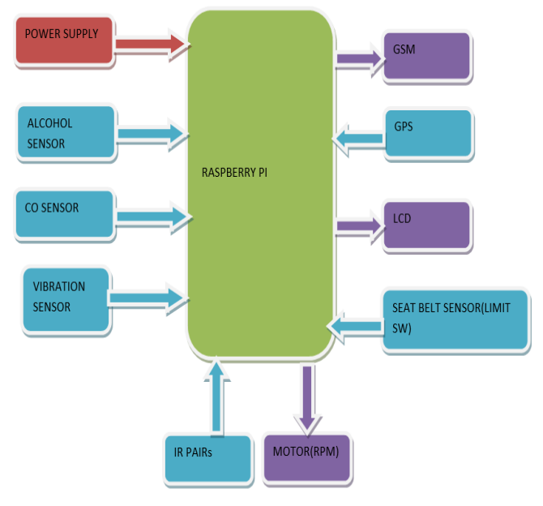

Fig. Block Diagram of the System

# CHAPTER – 4

## COMPONENTS

1. **Rasberry Pi 3**

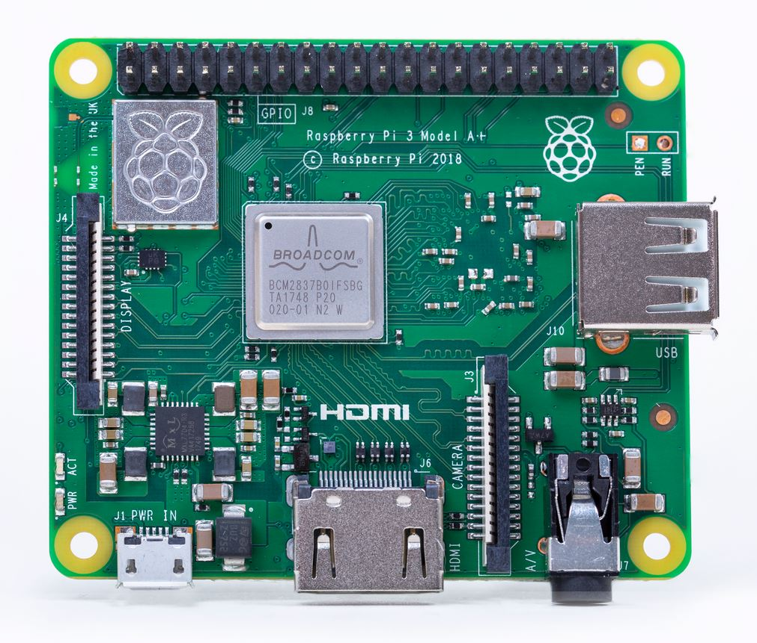

Raspberry Pi is a mini computer. The Raspberry Pi Zero is a 1.4GHz 64-bit quad-core processor, dual-band wireless LAN, Bluetooth 4.2/BLE, faster Ethernet, and Power-over-Ethernet support (with separate PoE HAT.**Raspberry Pi 3** Model B was released in February 2016.

1. **Alcohol Sensor**

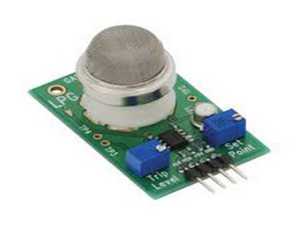

An alcohol sensor detects the level of alcohol gas in the air and gives the analog output reading. The sensor gets activated at temperatures ranging from -10 to 50° C with a power supply which is less than 150 Ma to 5V. It is long life, high compassion and faster.

1. **CO sensor**

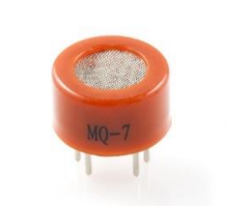

It is used to know weather in the accident the vehicle is burned. It is easy-to-use Carbon Monoxide (CO) sensor, suitable for sensing CO concentrations in the air. The MQ-7 can recognize CO-gas concentrations anywhere ranges from 20 to 2000ppm.[2] It has a high sensitivity and response time is faster. The CO sensor's output is an analog resistance.

1. Vibration Sensor

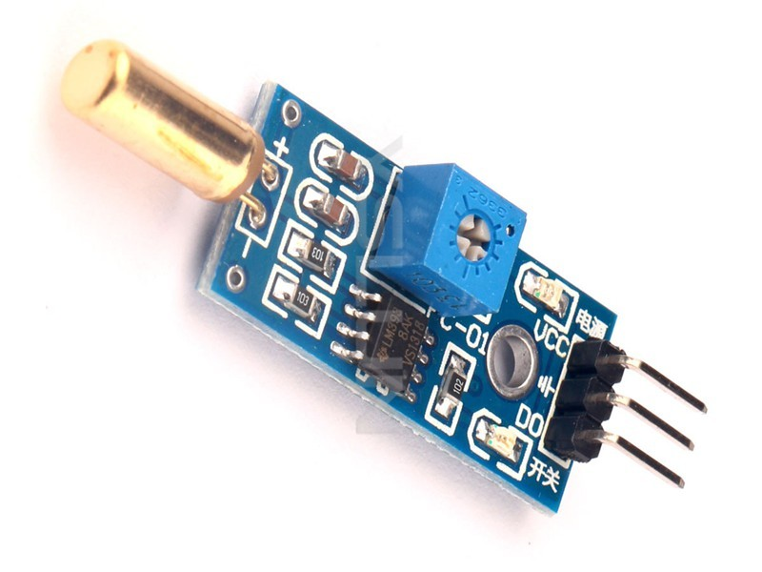

Vibration sensors are piezoelectric accelerometers that sense vibration. They are used for measuring fluctuating accelerations or speeds or for normal vibration measurement. Maintenance professionals use the sensors in order to predict the maintenance of the machinery, to reduce overall costs and increase the performance of the machinery.

Examples of applications where the vibration sensors are used: process control systems, aerial navigation and underwater-applications. Frequency range from 0.2 up to 2500 Hz. The operating temperature of these sensors is between -50°C and +85°C.

1. **GSM Module**

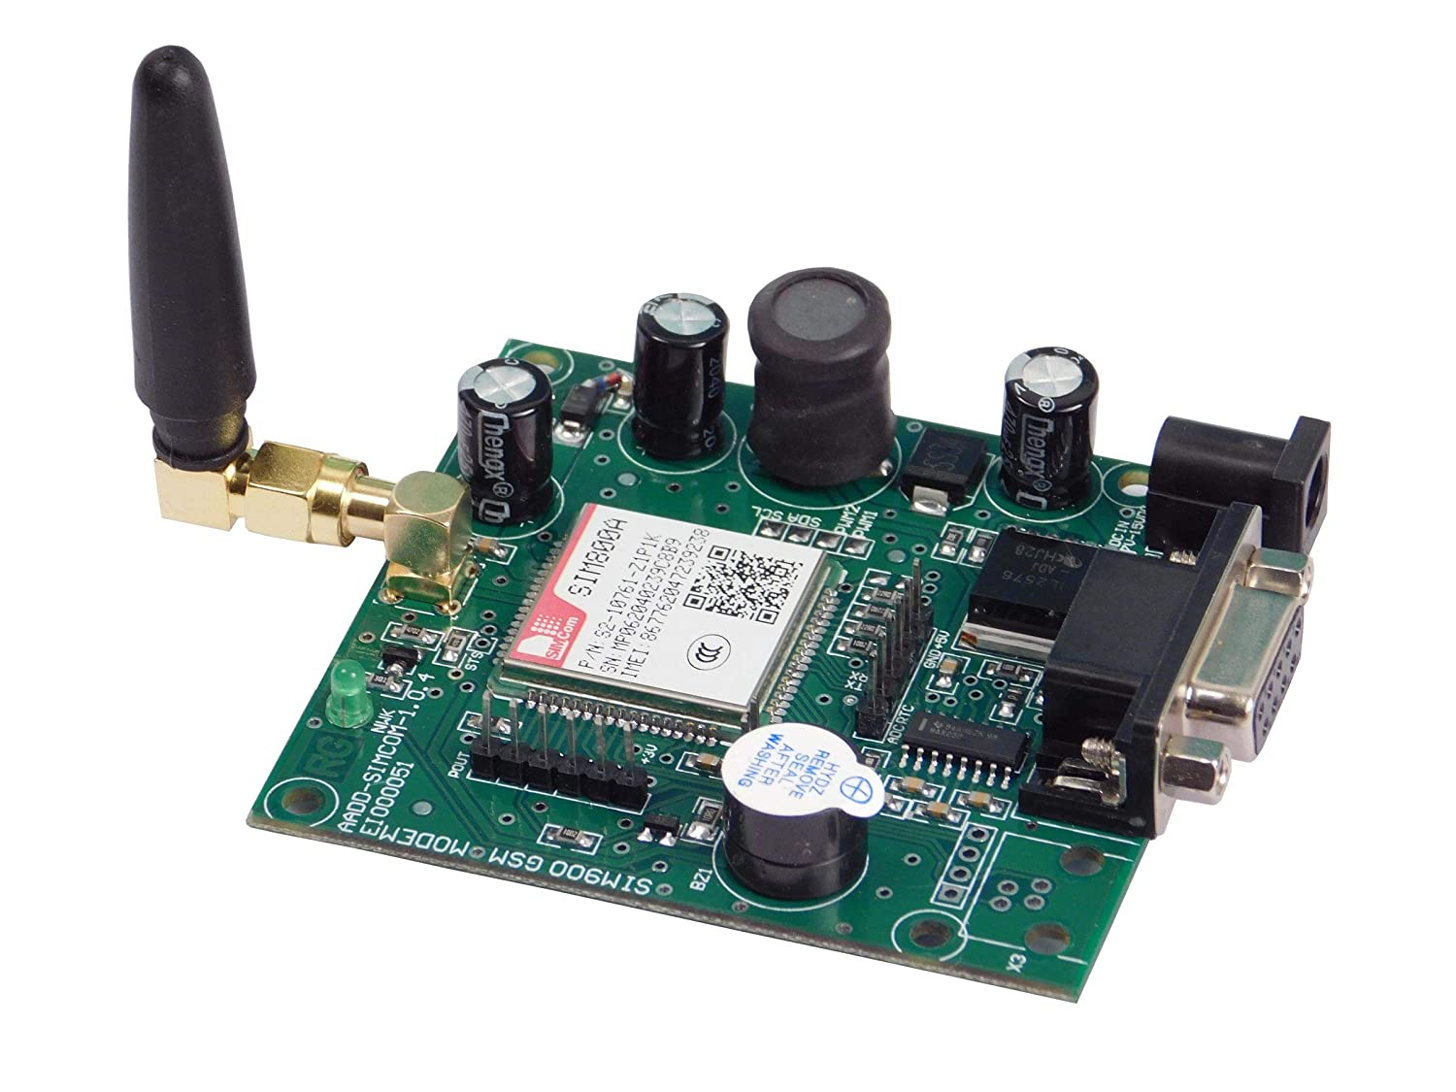

GSM is Global System for Mobile communication i.e. it is a digital mobile telephone system that is widely used in many parts of the world. GSM uses a variation of TDMA and is the most widely used of the three digital technologies TDMA, GSM, and CDMA. GSM converts and compresses data, then sends it down a channel with two other streams of user data. GSM receives the message and gets activated and sends the alert message. It is connected to the raspberry pi controller. It allows broadcast message in TEXT format.

1. 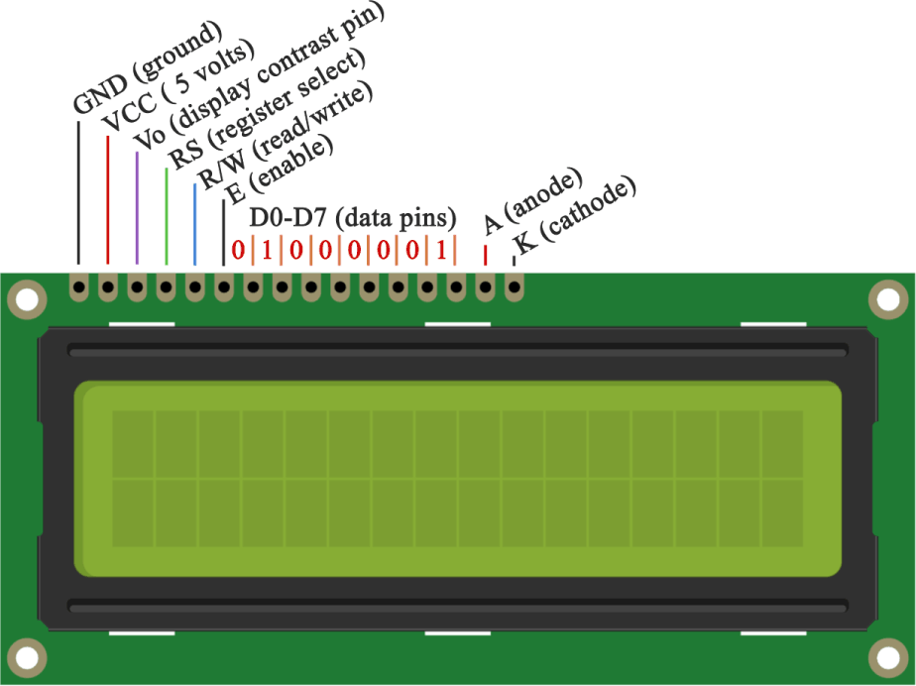**LCD Display**

The Liquid Crystal library allows you to control LCD displays that are compatible with the Hitachi HD44780 driver. There are many of them out there, and you can usually tell them by the 16-pin interface.This example sketch prints "Hello World!" to the LCD and shows the time in seconds since the Arduino was reset.

1. **IR Pairs**

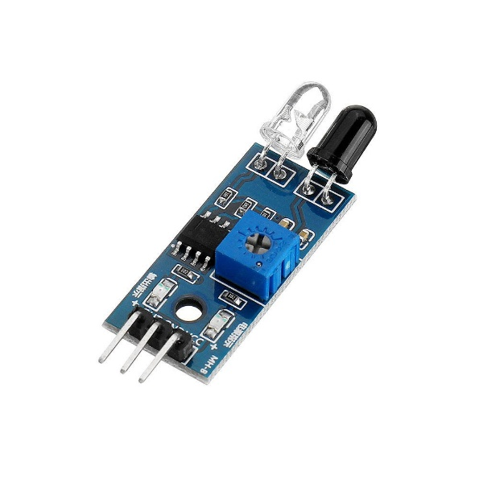

The IR pairs is used by the DC motor for speed in pulses and whether the seat belt slot is locked or not.

1. **GPS Module**

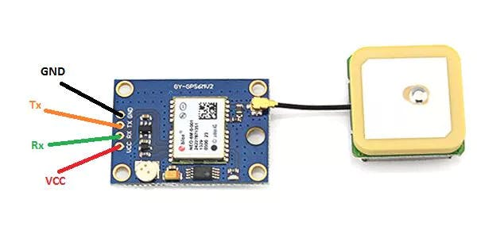

A Global Positioning System (GPS) is a exploration device or GPS receiver, or simply we can say GPS is a device which is capable of receiving information from GPS satellites and then to enclose the geographical position of vehicle or any moving device.

1. **Servo Motor**

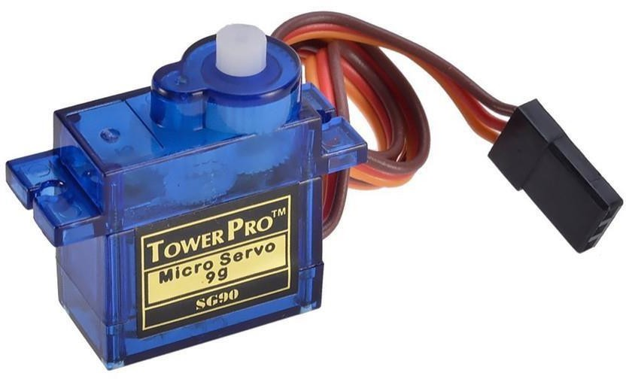

Servo motors are high torque motors which are commonly used in robotics and several

other applications due to the fact that it’s easy to control their rotation. Servo motors have

a geared output shaft which can be electrically controlled to turn one degree at a time.

For the sake of control, unlike normal DC motors, servo motors usually have an

additional pin asides the two power pins (Vcc and GND) which is the signal pin. The

signal pin is used to control the servo motor, turning its shaft to any desired angle.

1. 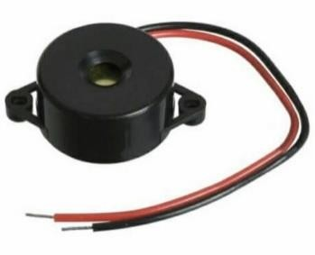**Piezo Buzzer**

In simplest terms, a piezo buzzer is a type of electronic device that’s used to produce a tone, alarm or sound. It’s lightweight with a simple construction, and it’s typically a low-cost product. Yet at the same time, depending on the piezo ceramic buzzer specifications, it’s also reliable and can be constructed in a wide range of sizes that work across varying frequencies to produce different sound outputs.

# CHAPTER – 5

## SYSTEM SOFTWARE DESIGN & RESULT

The development environment is done by merely a set of python functions that can be called for code. The flow chart of the system is shown in figure 10. At the first we have to initialize the system i.e. Raspberry pi module, GSM and GPS module with the basic values that alcohol is not detected and seat belt is not put up, and speed is zero. So, when the system gets started GPS gets initialized which receives the signal from the satellite and transfer the latitude and longitude value to the receiver. GSM receives the message and then it gets started through which the message is been send to emergency server numbers. While travelling if the accident occurs then it is been sensed by the vibration sensor, which gives indication to the system to send the alert message to the nearby ambulance, police station and insurance office numbers given in the program. The alert message includes seat belt is put on or not, alcohol presence, speed of the vehicle and also whether there is fire extinguisher. A threshold value is been set to which if the value goes beyond the threshold value then the alert message is been send. Therefore, the details of the car like spot, time, seat belt put on are updated from the GPS to the users or the server via GSM.

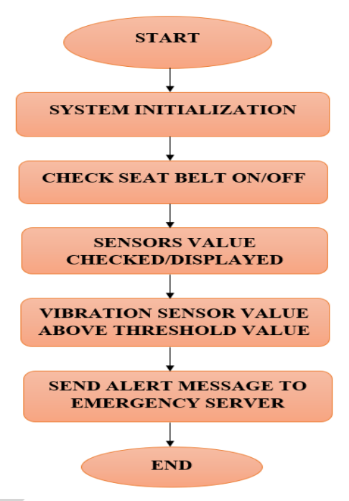

Fig. Flow Chart

# CHAPTER – 6

## PROJECT DESIGN

## 

## Fig. Project Design

## PYTHON CODE

#!/usr/bin/python

import time

import RPi.GPIO as GPIO

import pio

import Ports

#import serial

GPIO.setmode(GPIO.BOARD)

GPIO.setwarnings(False)

pio.uart=Ports.UART () # Define serial port

'''

define pin for lcd

'''

# Timing constants

E_PULSE = 0.0005

E_DELAY = 0.0005

delay = 1

buzzer=37

# Define GPIO to LCD mapping

LCD_RS = 7

LCD_E = 11

LCD_D4 = 12

LCD_D5 = 13

LCD_D6 = 15

LCD_D7 = 16

alcohol_Sensor = 18

relay = 22

seat_belt_Sensor = 29

vibration_sensor = 33

relay = 32

Buzzer= 31

GPIO.setup(LCD_E, GPIO.OUT) # E

GPIO.setup(LCD_RS, GPIO.OUT) # RS

GPIO.setup(LCD_D4, GPIO.OUT) # DB4

GPIO.setup(LCD_D5, GPIO.OUT) # DB5

GPIO.setup(LCD_D6, GPIO.OUT) # DB6

GPIO.setup(LCD_D7, GPIO.OUT)

GPIO.setup(alcohol_Sensor, GPIO.IN)

GPIO.setup(seat_belt_Sensor, GPIO.IN)

GPIO.setup(vibration_sensor, GPIO.IN)

GPIO.setup(relay , GPIO.OUT)

GPIO.setup(Buzzer, GPIO.OUT)

# Define some device constants

LCD_WIDTH = 16 # Maximum characters per line

LCD_CHR = True

LCD_CMD = False

LCD_LINE_1 = 0x80 # LCD RAM address for the 1st line

LCD_LINE_2 = 0xC0 # LCD RAM address for the 2nd line

'''

Function Name :lcd_init()

Function Description : this function is used to initialized lcd by sending the different commands

'''

def lcd_init():

# Initialise display

lcd_byte(0x33,LCD_CMD) # 110011 Initialise

lcd_byte(0x32,LCD_CMD) # 110010 Initialise

lcd_byte(0x06,LCD_CMD) # 000110 Cursor move direction

lcd_byte(0x0C,LCD_CMD) # 001100 Display On,Cursor Off, Blink Off

lcd_byte(0x28,LCD_CMD) # 101000 Data length, number of lines, font size

lcd_byte(0x01,LCD_CMD) # 000001 Clear display

time.sleep(E_DELAY)

'''

Function Name :lcd_byte(bits ,mode)

Fuction Name :the main purpose of this function to convert the byte data into bit and send to lcd port

'''

def lcd_byte(bits, mode):

# Send byte to data pins

# bits = data

# mode = True for character

# False for command

GPIO.output(LCD_RS, mode) # RS

# High bits

GPIO.output(LCD_D4, False)

GPIO.output(LCD_D5, False)

GPIO.output(LCD_D6, False)

GPIO.output(LCD_D7, False)

if bits&0x10==0x10:

GPIO.output(LCD_D4, True)

if bits&0x20==0x20:

GPIO.output(LCD_D5, True)

if bits&0x40==0x40:

GPIO.output(LCD_D6, True)

if bits&0x80==0x80:

GPIO.output(LCD_D7, True)

# Toggle 'Enable' pin

lcd_toggle_enable()

# Low bits

GPIO.output(LCD_D4, False)

GPIO.output(LCD_D5, False)

GPIO.output(LCD_D6, False)

GPIO.output(LCD_D7, False)

if bits&0x01==0x01:

GPIO.output(LCD_D4, True)

if bits&0x02==0x02:

GPIO.output(LCD_D5, True)

if bits&0x04==0x04:

GPIO.output(LCD_D6, True)

if bits&0x08==0x08:

GPIO.output(LCD_D7, True)

# Toggle 'Enable' pin

lcd_toggle_enable()

'''

Function Name : lcd_toggle_enable()

Function Description:basically this is used to toggle Enable pin

'''

def lcd_toggle_enable():

# Toggle enable

time.sleep(E_DELAY)

GPIO.output(LCD_E, True)

time.sleep(E_PULSE)

GPIO.output(LCD_E, False)

time.sleep(E_DELAY)

'''

Function Name :lcd_string(message,line)

Function Description :print the data on lcd

'''

def lcd_string(message,line):

# Send string to display

message = message.ljust(LCD_WIDTH," ")

lcd_byte(line, LCD_CMD)

for i in range(LCD_WIDTH):

lcd_byte(ord(message[i]),LCD_CHR)

lcd_init()

lcd_string(" Welcome to our",LCD_LINE_1)

lcd_string(" IOE Project",LCD_LINE_2)

time.sleep(0.5)

lcd_byte(0x01,LCD_CMD) # 000001 Clear display

lcd_string("Simulation Demo ",LCD_LINE_1)

lcd_string("Smart Car System",LCD_LINE_2)

time.sleep(0.5)

while 1:

# Print out results

alcohol_data = GPIO.input(alcohol_Sensor)

seat_belt_data = GPIO.input(seat_belt_Sensor)

vibration_data = GPIO.input(vibration_sensor)

if(vibration_data == False):

if(seat_belt_data == True):

lcd_byte(0x01,LCD_CMD) # 000001 Clear display

lcd_string(" Seat Belt is UP ",LCD_LINE_1)

lcd_string(" Ready-To-Go ",LCD_LINE_2)

time.sleep(0.5)

if(alcohol_data == True):

lcd_string(" Caution !! ",LCD_LINE_1)

lcd_string("GasLeak Detected",LCD_LINE_2)

time.sleep(0.2)

lcd_string(" You Cannot ",LCD_LINE_1)

lcd_string("Drive this car ",LCD_LINE_1)

time.sleep(0.5)

lcd_string("Contact Nearby",LCD_LINE_1)

lcd_string("Transport Services",LCD_LINE_2)

pio.uart.println("Contacting Nearby")

pio.uart.println("Dialing Nearby")

pio.uart.println("Mechanic")

pio.uart.println("AT+CMGF=Mr Mechanic")

pio.uart.println("AT+CMGS=\"+918662610349\"\r")

pio.uart.println("Need Help at https://goo.gl/maps/yVt5AAisBW9B5s53A")

time.sleep(0.5)

pio.uart.println("Dialing Nearby")

pio.uart.println("Transportation Services")

pio.uart.println("Available : OLA ; UBER ; MERU")

pio.uart.println("AT+CMGF=UBER")

pio.uart.println("AT+CMGS=\"+918665761039\"\r")

pio.uart.println("AT+CMGF= Connected")

pio.uart.println("Need Cab at https://goo.gl/maps/yVt5AAisBW9B5s53A")

GPIO.output(relay, False)

GPIO.output(Buzzer, True)

time.sleep(0.5)

GPIO.output(Buzzer, False)

time.sleep(0.5)

else:

lcd_byte(0x01,LCD_CMD) # 000001 Clear display

lcd_string("System Chck Done",LCD_LINE_1)

lcd_string("Engine Active",LCD_LINE_2)

time.sleep(0.2)

lcd_string("Have a Safe Ride",LCD_LINE_1)

GPIO.output(Buzzer, False)

GPIO.output(relay, True)

else:

lcd_byte(0x01,LCD_CMD) # 000001 Clear display

lcd_string(" Please Wear",LCD_LINE_1)

lcd_string("Your Seat Belt",LCD_LINE_2)

GPIO.output(relay, False)

GPIO.output(Buzzer, True)

time.sleep(0.5)

GPIO.output(Buzzer, False)

time.sleep(0.5)

else:

pio.uart.println("AT")

pio.uart.println("AT+CMGF=1")

pio.uart.println("AT+CMGS=\"+919967322355\"\r")

pio.uart.println("Accident Happened ")

pio.uart.println("GPS Co-Ordinates")

for x in range(100):

Data=pio.uart.recv()

pio.uart.print(Data)

# CHAPTER – 7

## FUTURE SCOPE

This system can be further implemented with mishap impediment scheme. That is to identify and avoid accidents before it happens. We can also add a camera that might serve as a black box like the one in aeroplane, so that we can capture the snap of the events so that we know the reason behind the accident. The one who is driving has consume alcohol then by giving alarm the vehicle can be stopped.This system can be further enhanced and even extent to IOT applications. This system is very efficient in reducing the road accidents and prevent overspeeding in restricted zones. It also a combination of both accident alert system and theft prevention system. In existing project, there is no autonomous speed restriction in the vehicle to avoid accidents. We can also add live tracking of speed and location in the mobile application. If we detect the living things which are crossing before the vehicle we can prevent many accidents and can save, millions of lives.

# CHAPTER – 8

## CONCLUSION

The proposed system mainly designed in order to avoid accidents and to alert when an accident happens. An effective solution is provided to develop the intelligent vehicle which will operates on safest speed at critical zones and send alert message to the family and emergency centres when the vehicle is met with an accident. Hence it is concluded from the above study that the use of Automatic vehicle speed control and accident alert system to minimize unwanted accidents to a great extent compared to normal behaviour. The proposed system provides the emergency medical service as soon as possible and to avoid the mortality. It is to provide the details of the accident occurred and area of the accident with other information. It helps to easily provide facility and help to the victim of the accident. GSM is used to provide information regarding the accident and GPS module is used to traces the location of the vehicle.

# 